Steps to Pull/Push react app Image from Repository in Docker hub and Run it on Remote Ubuntu Server

⚙️ Step-by-Step Setup
- Create a Image of React app : -

Docker Image: -
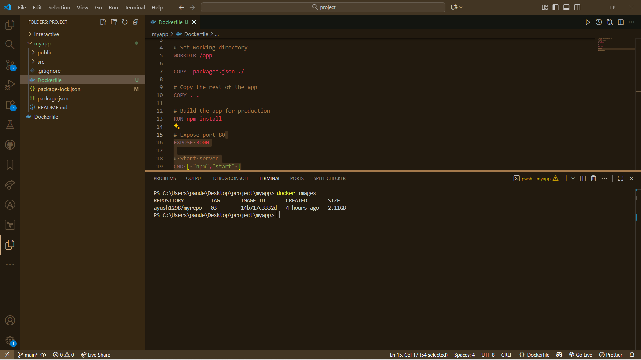

- Login on DockerHub And push this Image on DockerHub in your repo: -
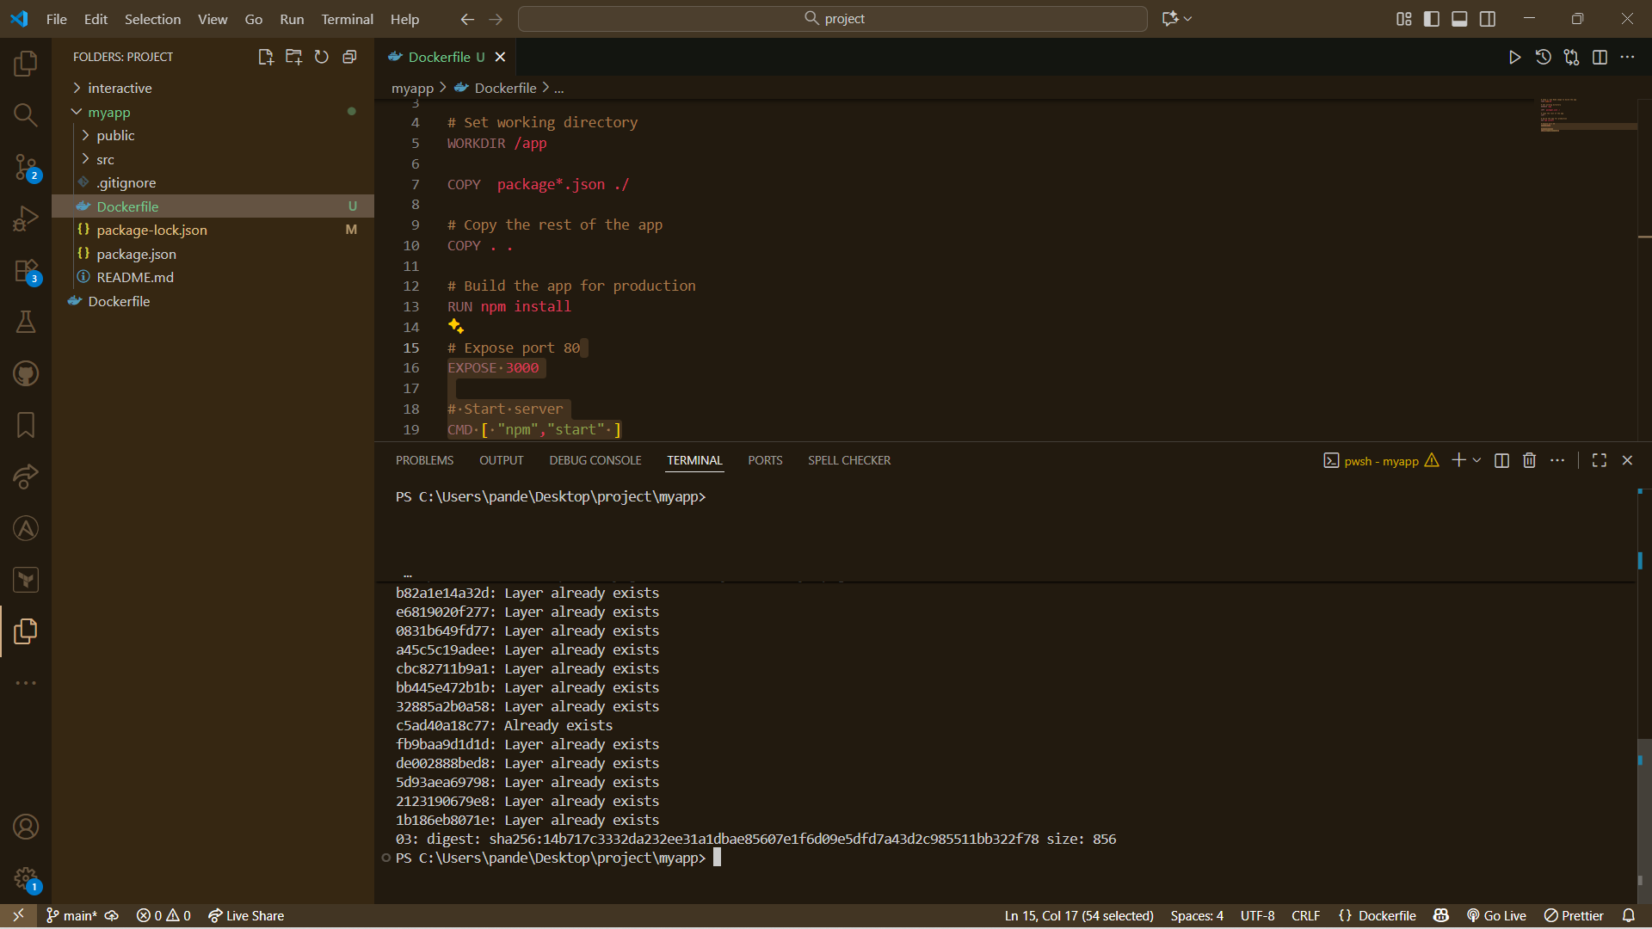
Docker Image Name: - ayush1298/myrepo:03

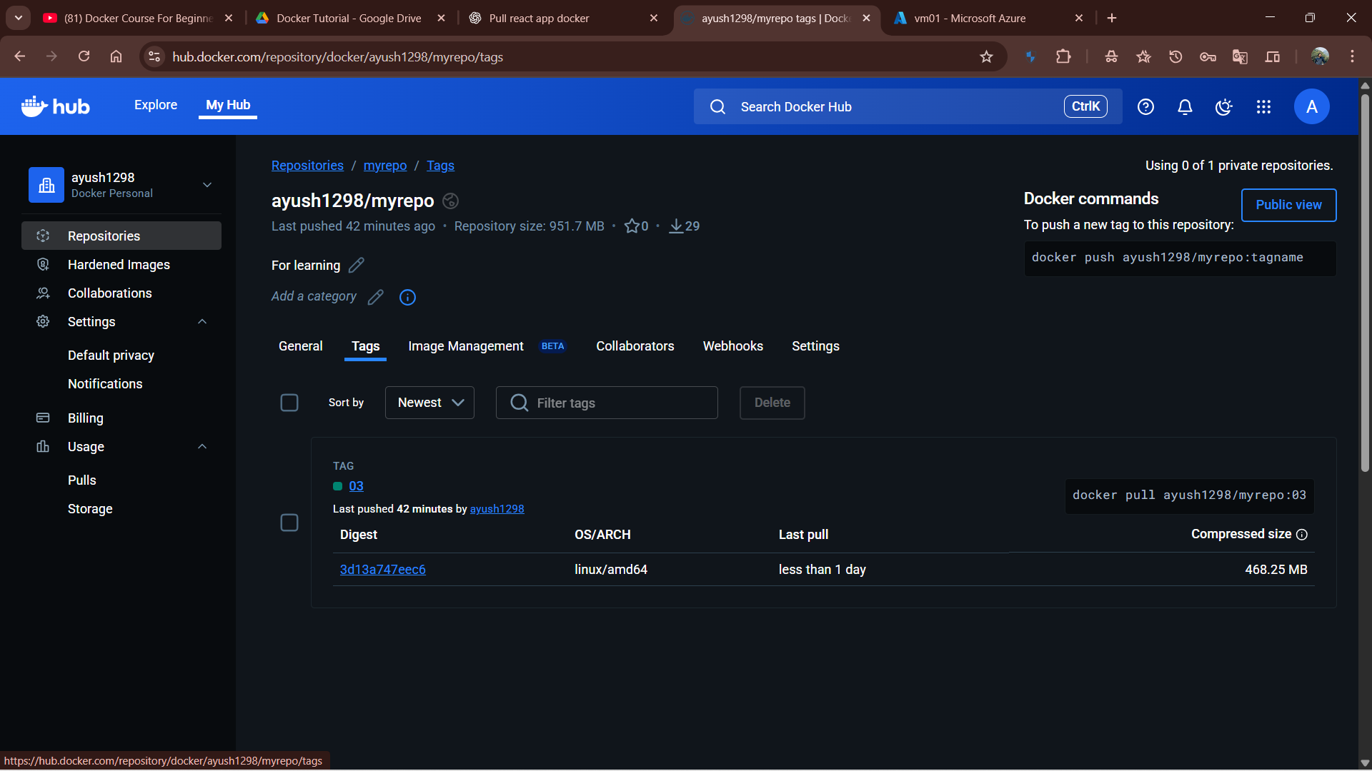

- Create Ubuntu Server on Azure: -
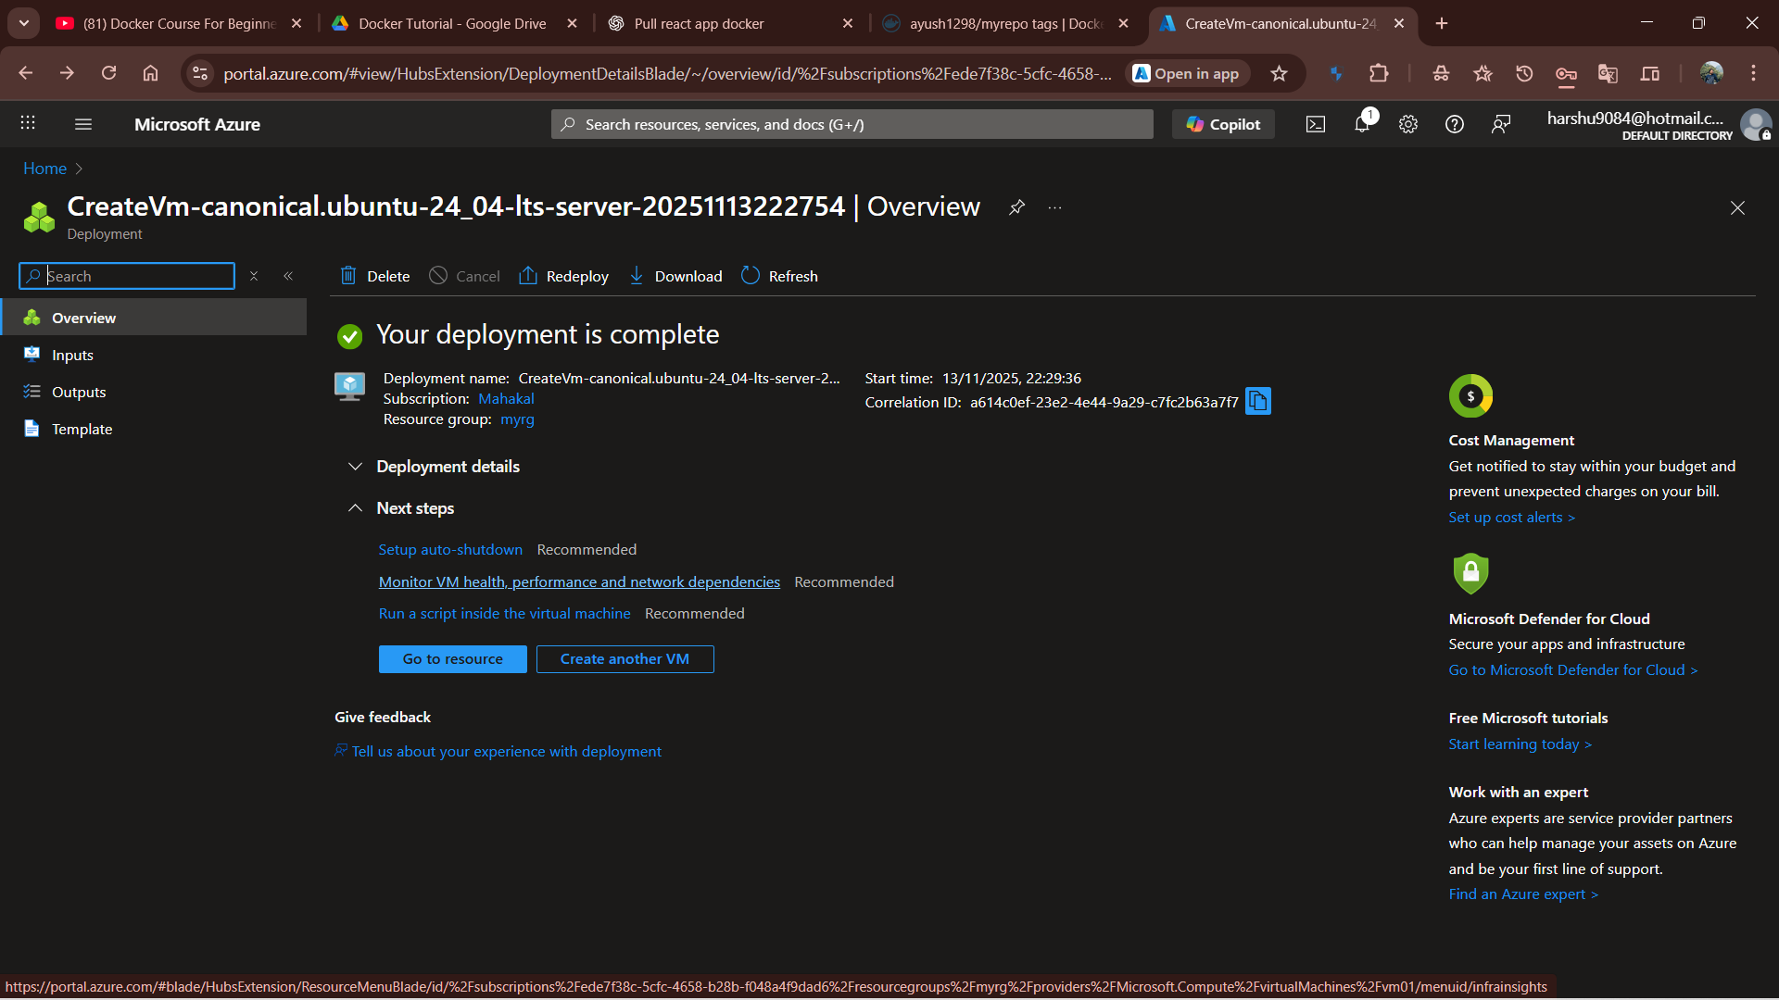

Login: -

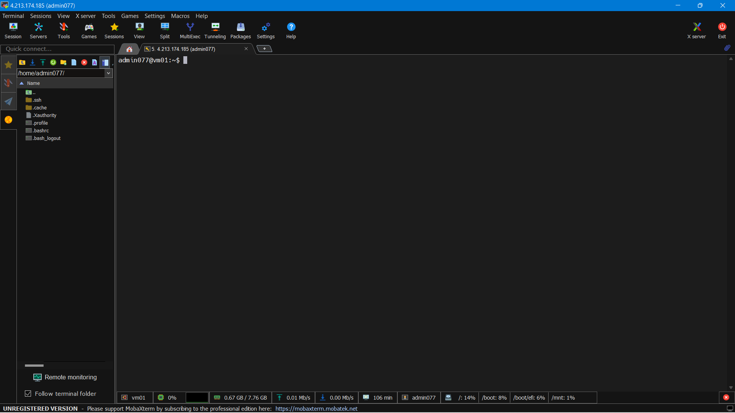

Steps to Install Docker in Remote Server: -

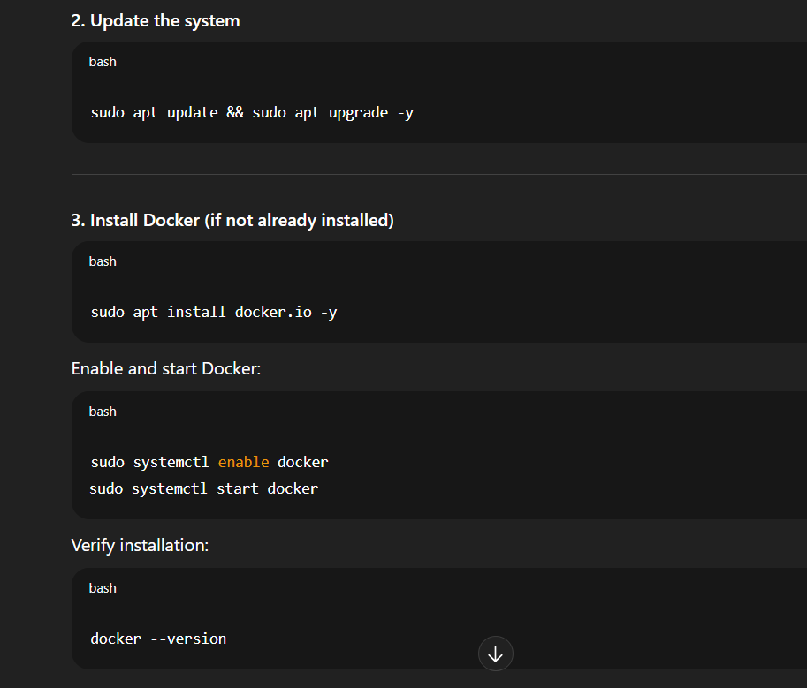
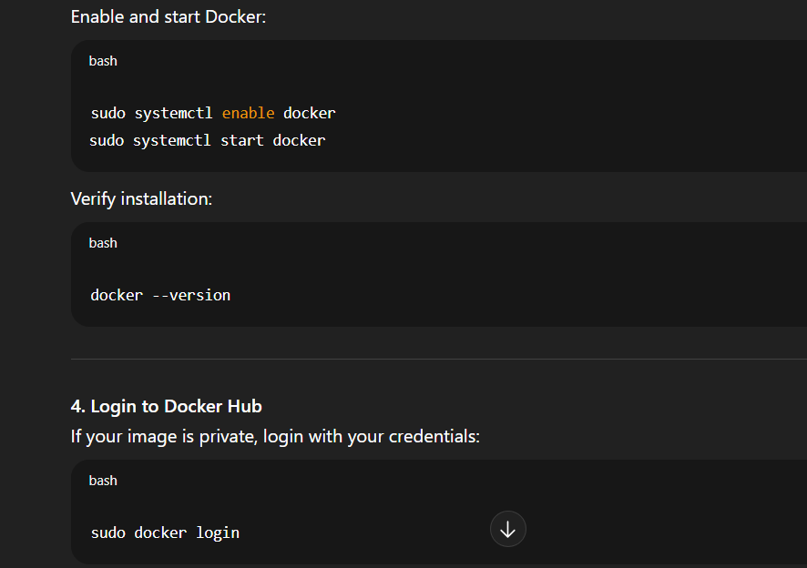
(Enter your Docker Hub username and password or token)
If it is a public image, you can skip this step.

- Pull your React app image from Docker Hub: -
Command: - sudo docker pull ayush1298/myrepo:03
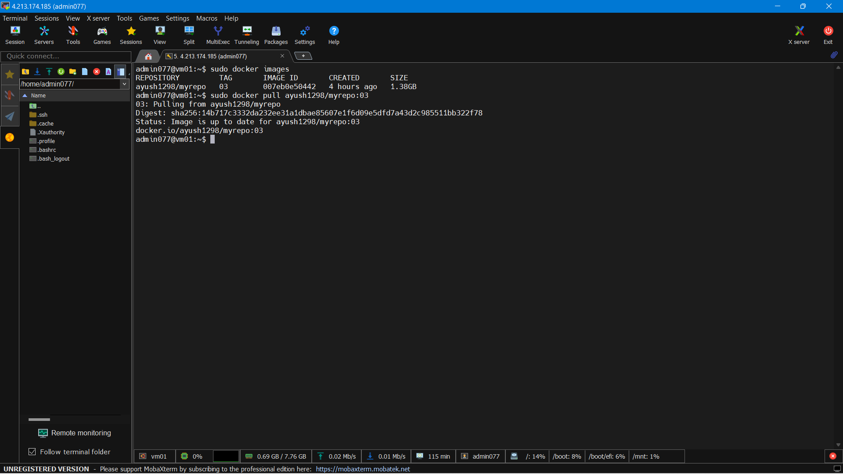

- Run your React app container
Run the container and map ports:
Command: - sudo docker run -d -p 80:3000 ayush1298/myrepo:03

- Verify the container is running
Command: - sudo docker ps

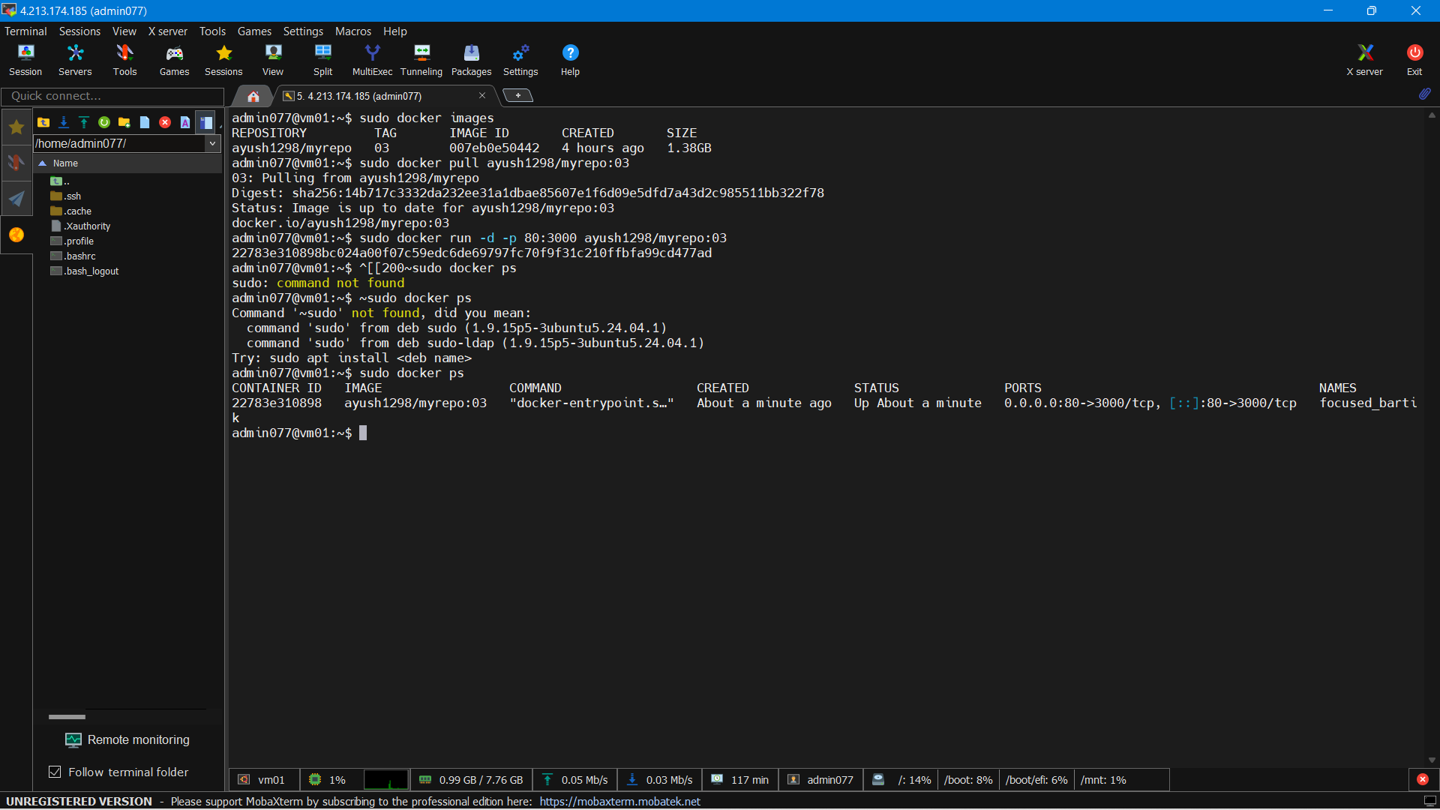
You should see your container listed.

- Open port 80 in Azure (important)
Go to your Azure Portal → Your VM → Networking → Inbound Port Rules
Add a rule to Allow TCP on port 80.

- Test the app in your browser
http://<your-vm-public-ip>

Output: -
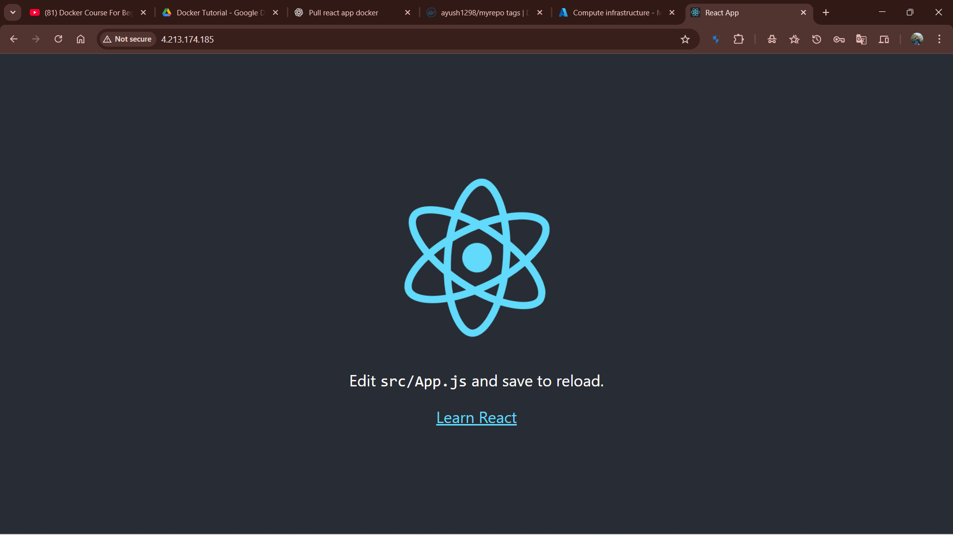
React app running 🎉

-------------------------------------------------------------------------------------------------------------

